Installing Git

* sudo apt install git # for ubuntu OS.
* sudo yum install git # for RedHat and Amazon Linux OS

Installing Maven on Amazon Linux

Pre-requisites:

1. java

sudo yum install java-1.8.0-openjdk # installing java jdk and jre.

* wget <https://dlcdn.apache.org/maven/maven-3/3.3.9/binaries/apache-maven-3.3.9-bin.tar.gz> -P /tmp

This command will download the maven 3.3.9 tar file from the maven index to the location

/tmp.

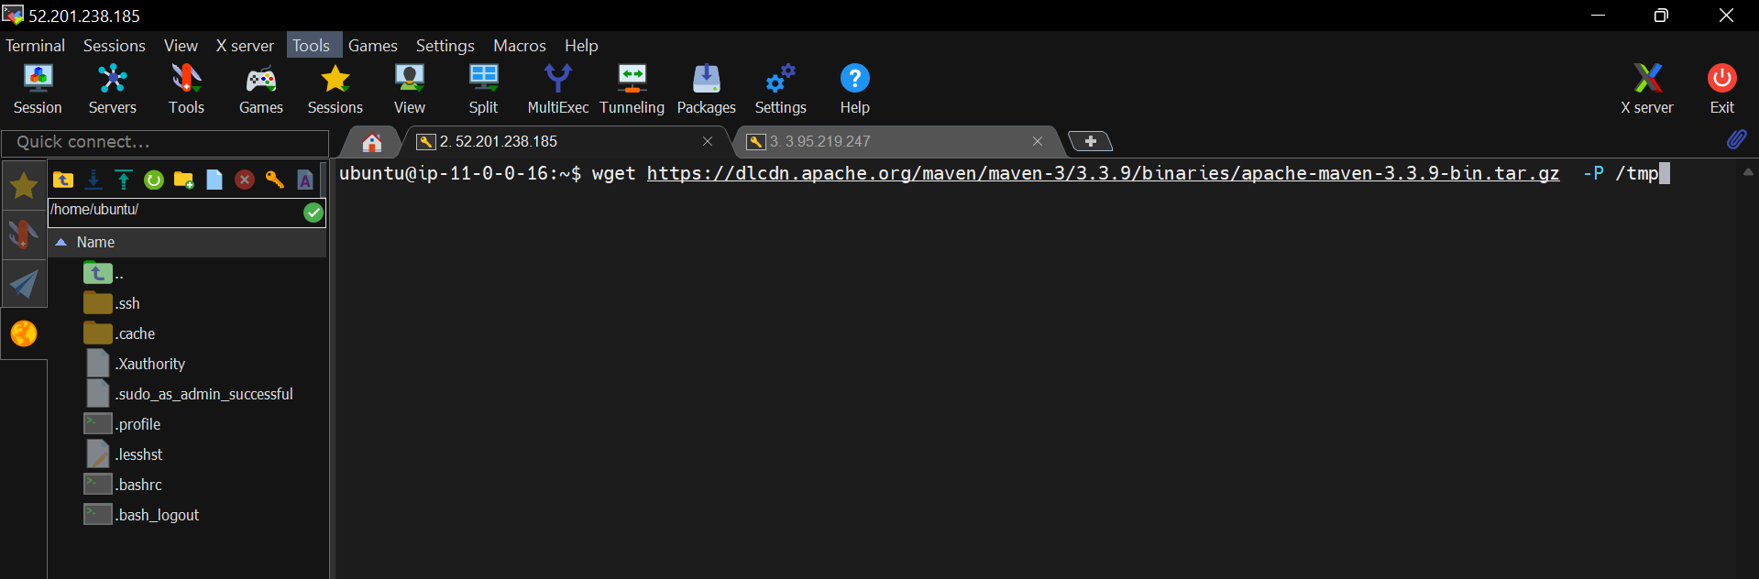

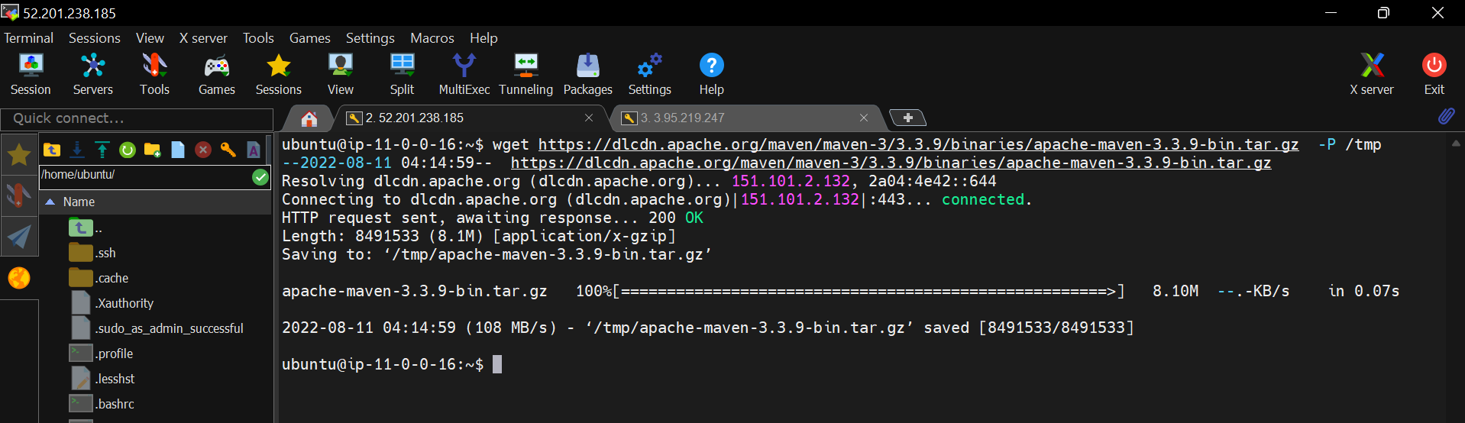

Maven downloaded.

We can see the Apache-maven tar file in /tmp directory.

Now, extract this tar to the location “/opt” directory.

* sudo tar xf /tmp/apache-maven-3.3.9-bin.tar.gz -C /opt

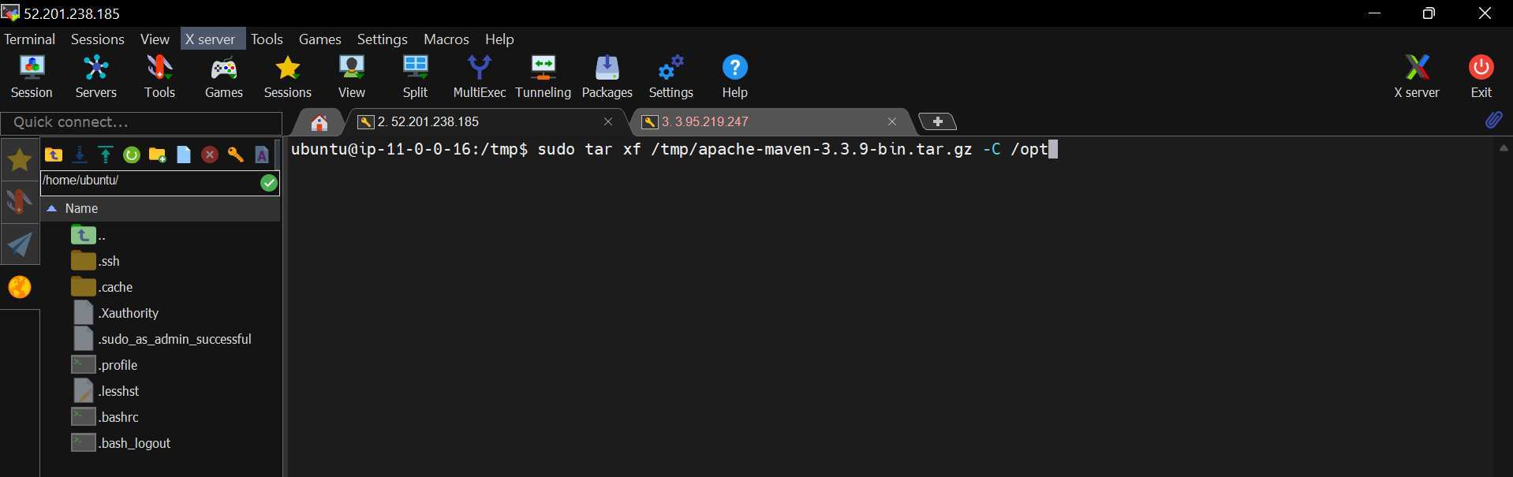

It’s extracted to “/opt” location, verify it.

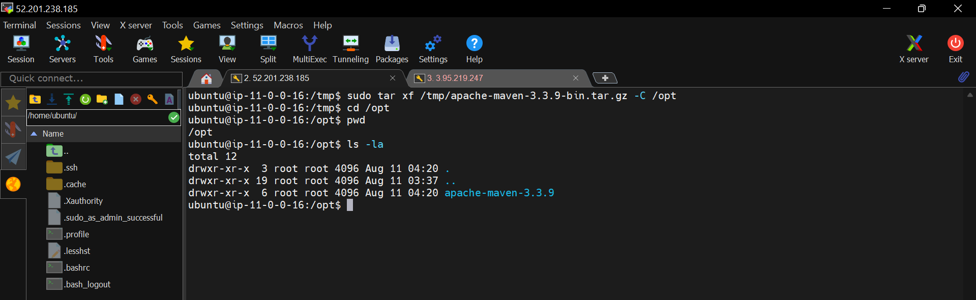

This is the maven installation directory.

Now,  create a symbolic link called “maven” leading to the Maven installation directory.

* sudo ln -s /opt/apache-maven-3.3.9 /opt/maven

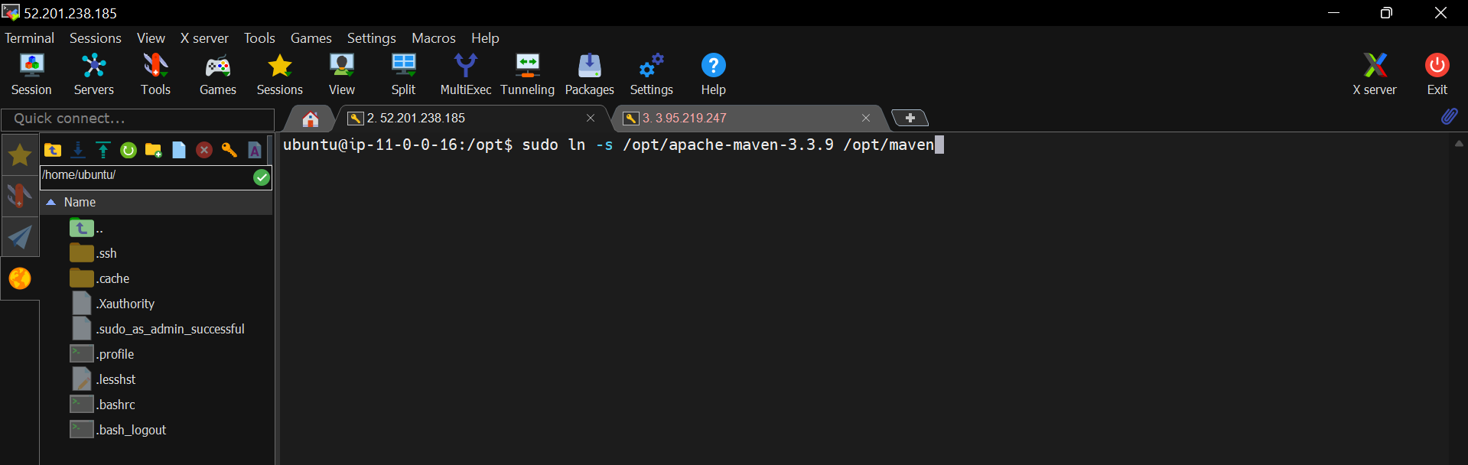

Symbolic link is created, verify it.

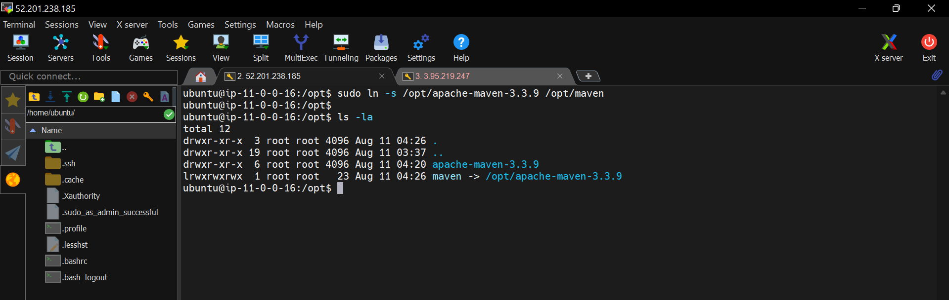

Now, Set Up Environment Variables

Create a file called “maven.sh” in the directory “/etc/profile.d/”.

* sudo touch /etc/profile.d/maven.sh

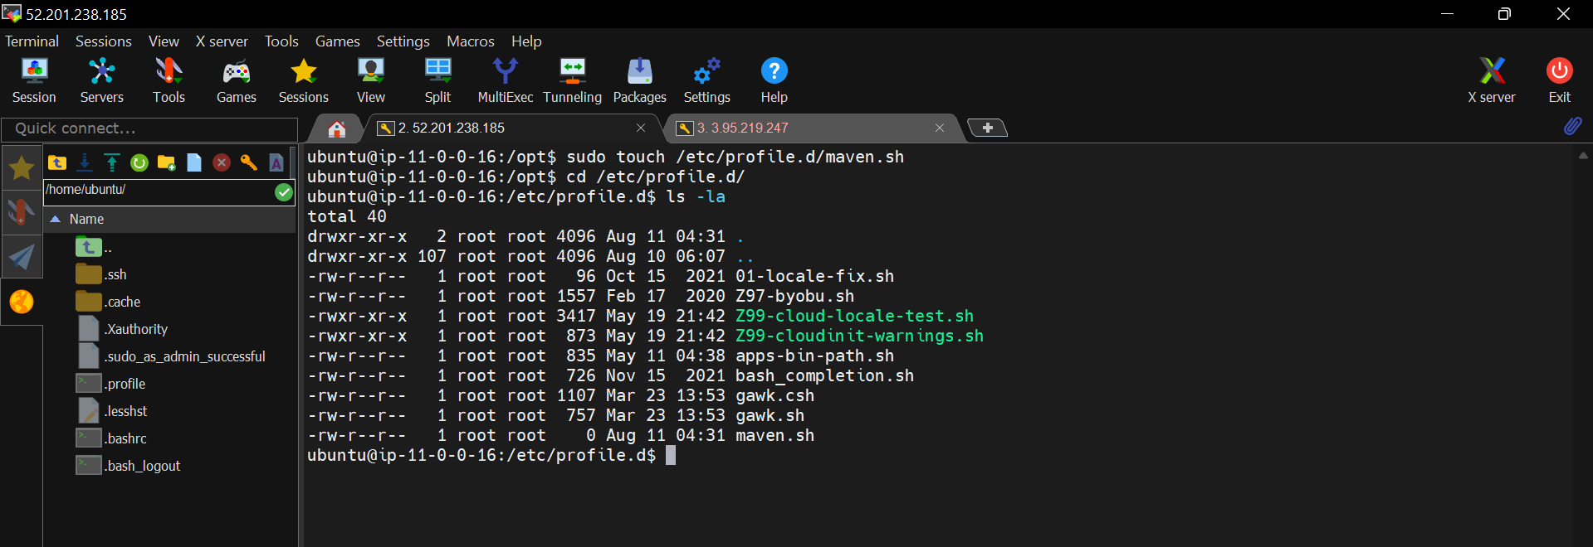

Now, edit this file using “nano” editor.

* sudo nano /etc/profile.d/maven.sh

copy the below code in the file “maven.sh”

export JAVA_HOME=/usr/lib/jvm/java-1.8.0-openjdk-1.8.0.332.b09-1.amzn2.0.2.x86_64

export M2_HOME=/opt/maven

export MAVEN_HOME=/opt/maven

export PATH=${M2_HOME}/bin:${PATH}

Here, we are exporting/adding the JAVA and MAVEN home path to PATH variable.

When, we are executing java or maven commands it will search for the java and maven executable files in this location. If it’s not found such files then throws error.

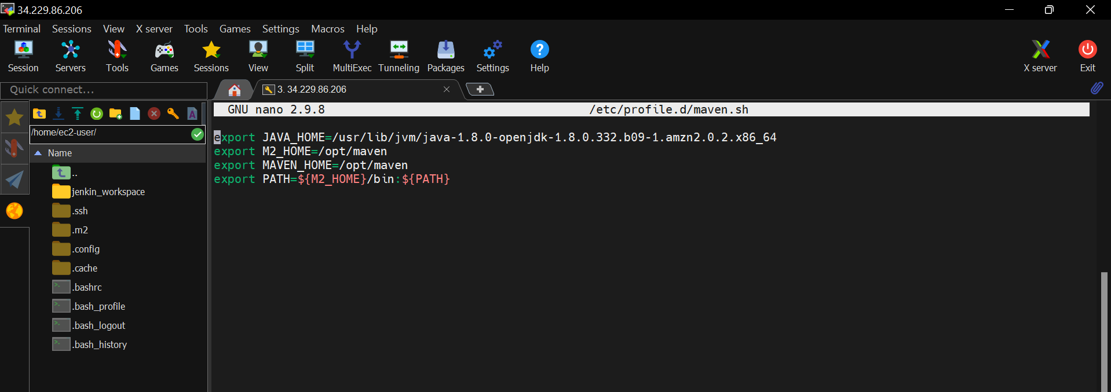

Save and close the file.

Ctl+s 🡺 save the file

Ctl+x 🡺 close the file

Now, make this “maven.sh” file as executable.

* sudo chmod +x /etc/profile.d/maven.sh

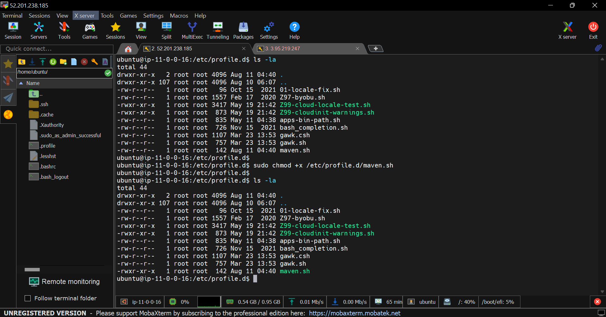

Now, load these maven configurations

* source /etc/profile.d/maven.sh

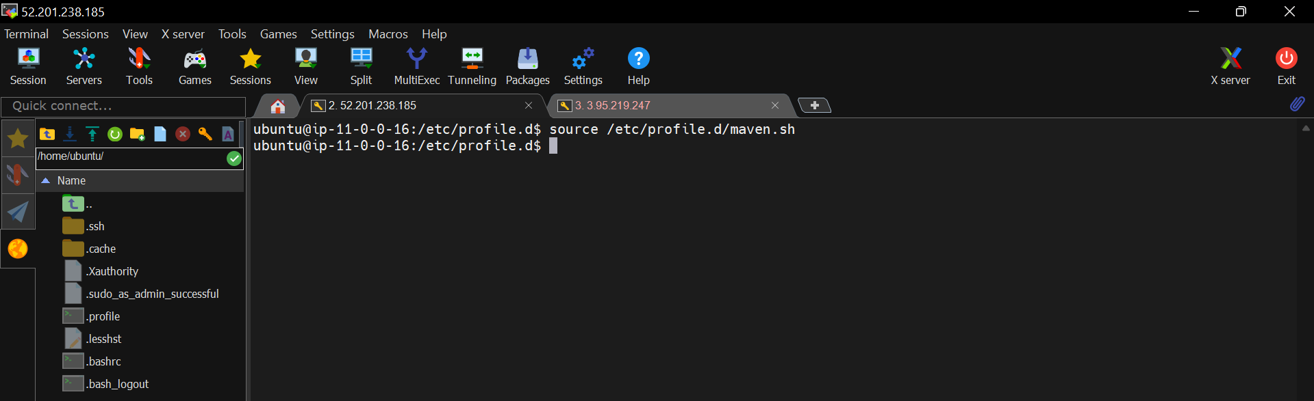

JAVA_HOME and MAVEN_HOME are exported successfully.

Now, verify the maven installation

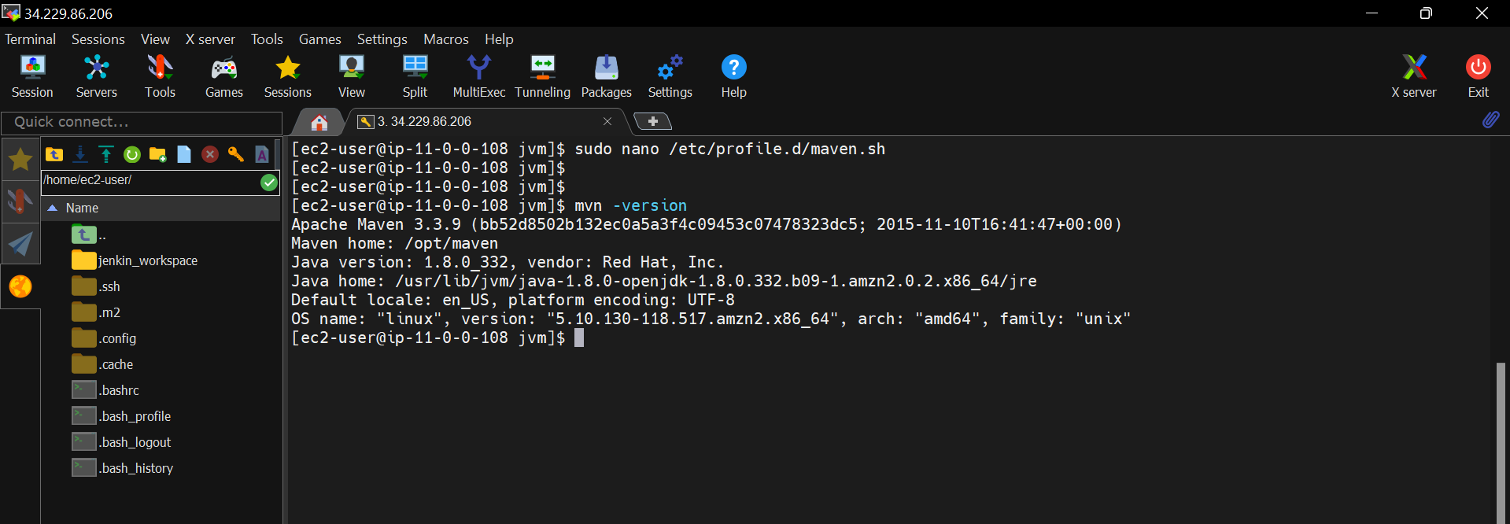

Maven installed successfully, we can see our configured maven and java home paths are using by maven.

Simple installation of maven

* sudo apt install maven

Install maven on Ubuntu

Pre-requisites:

1. Java

sudo apt install openjdk-8-jdk

* wget https://dlcdn.apache.org/maven/maven-3/3.3.9/binaries/apache-maven-3.3.9-bin.tar.gz -P /tmp
* sudo tar xf /tmp/apache-maven-3.3.9-bin.tar.gz -C /opt
* sudo ln -s /opt/apache-maven-3.3.9 /opt/maven
* touch /etc/profile.d/maven.sh
* sudo nano /etc/profile.d/maven.sh

copy the below code in the file “maven.sh”

export JAVA_HOME= /usr/lib/jvm/java-8-openjdk-amd64

export M2_HOME=/opt/maven

export MAVEN_HOME=/opt/maven

export PATH=${M2_HOME}/bin:${PATH}

Save and close the file.

Ctl+s 🡺 save the file

Ctl+x 🡺 close the file

* sudo chmod +x /etc/profile.d/maven.sh
* source /etc/profile.d/maven.sh

